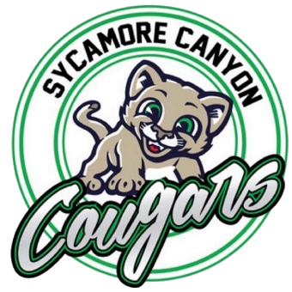
SYCAMORE CANYON SCHOOL

School Site Council
Agenda
Monday, November 6, 2023
TEAMS, 3:00 PM

- Call to Order

- Introductions

- Agenda and Minutes Review and Approval

- Items Scheduled for Discussion and/or Action

  - Review the meeting dates for the year.
  - Review/Revise the by-laws.
  - Review the Parent Involvement Policy.

- Public Communication

- Next Meeting – Monday, December 4, 2023

- Adjournment

